kiti eZebs axal saxls!

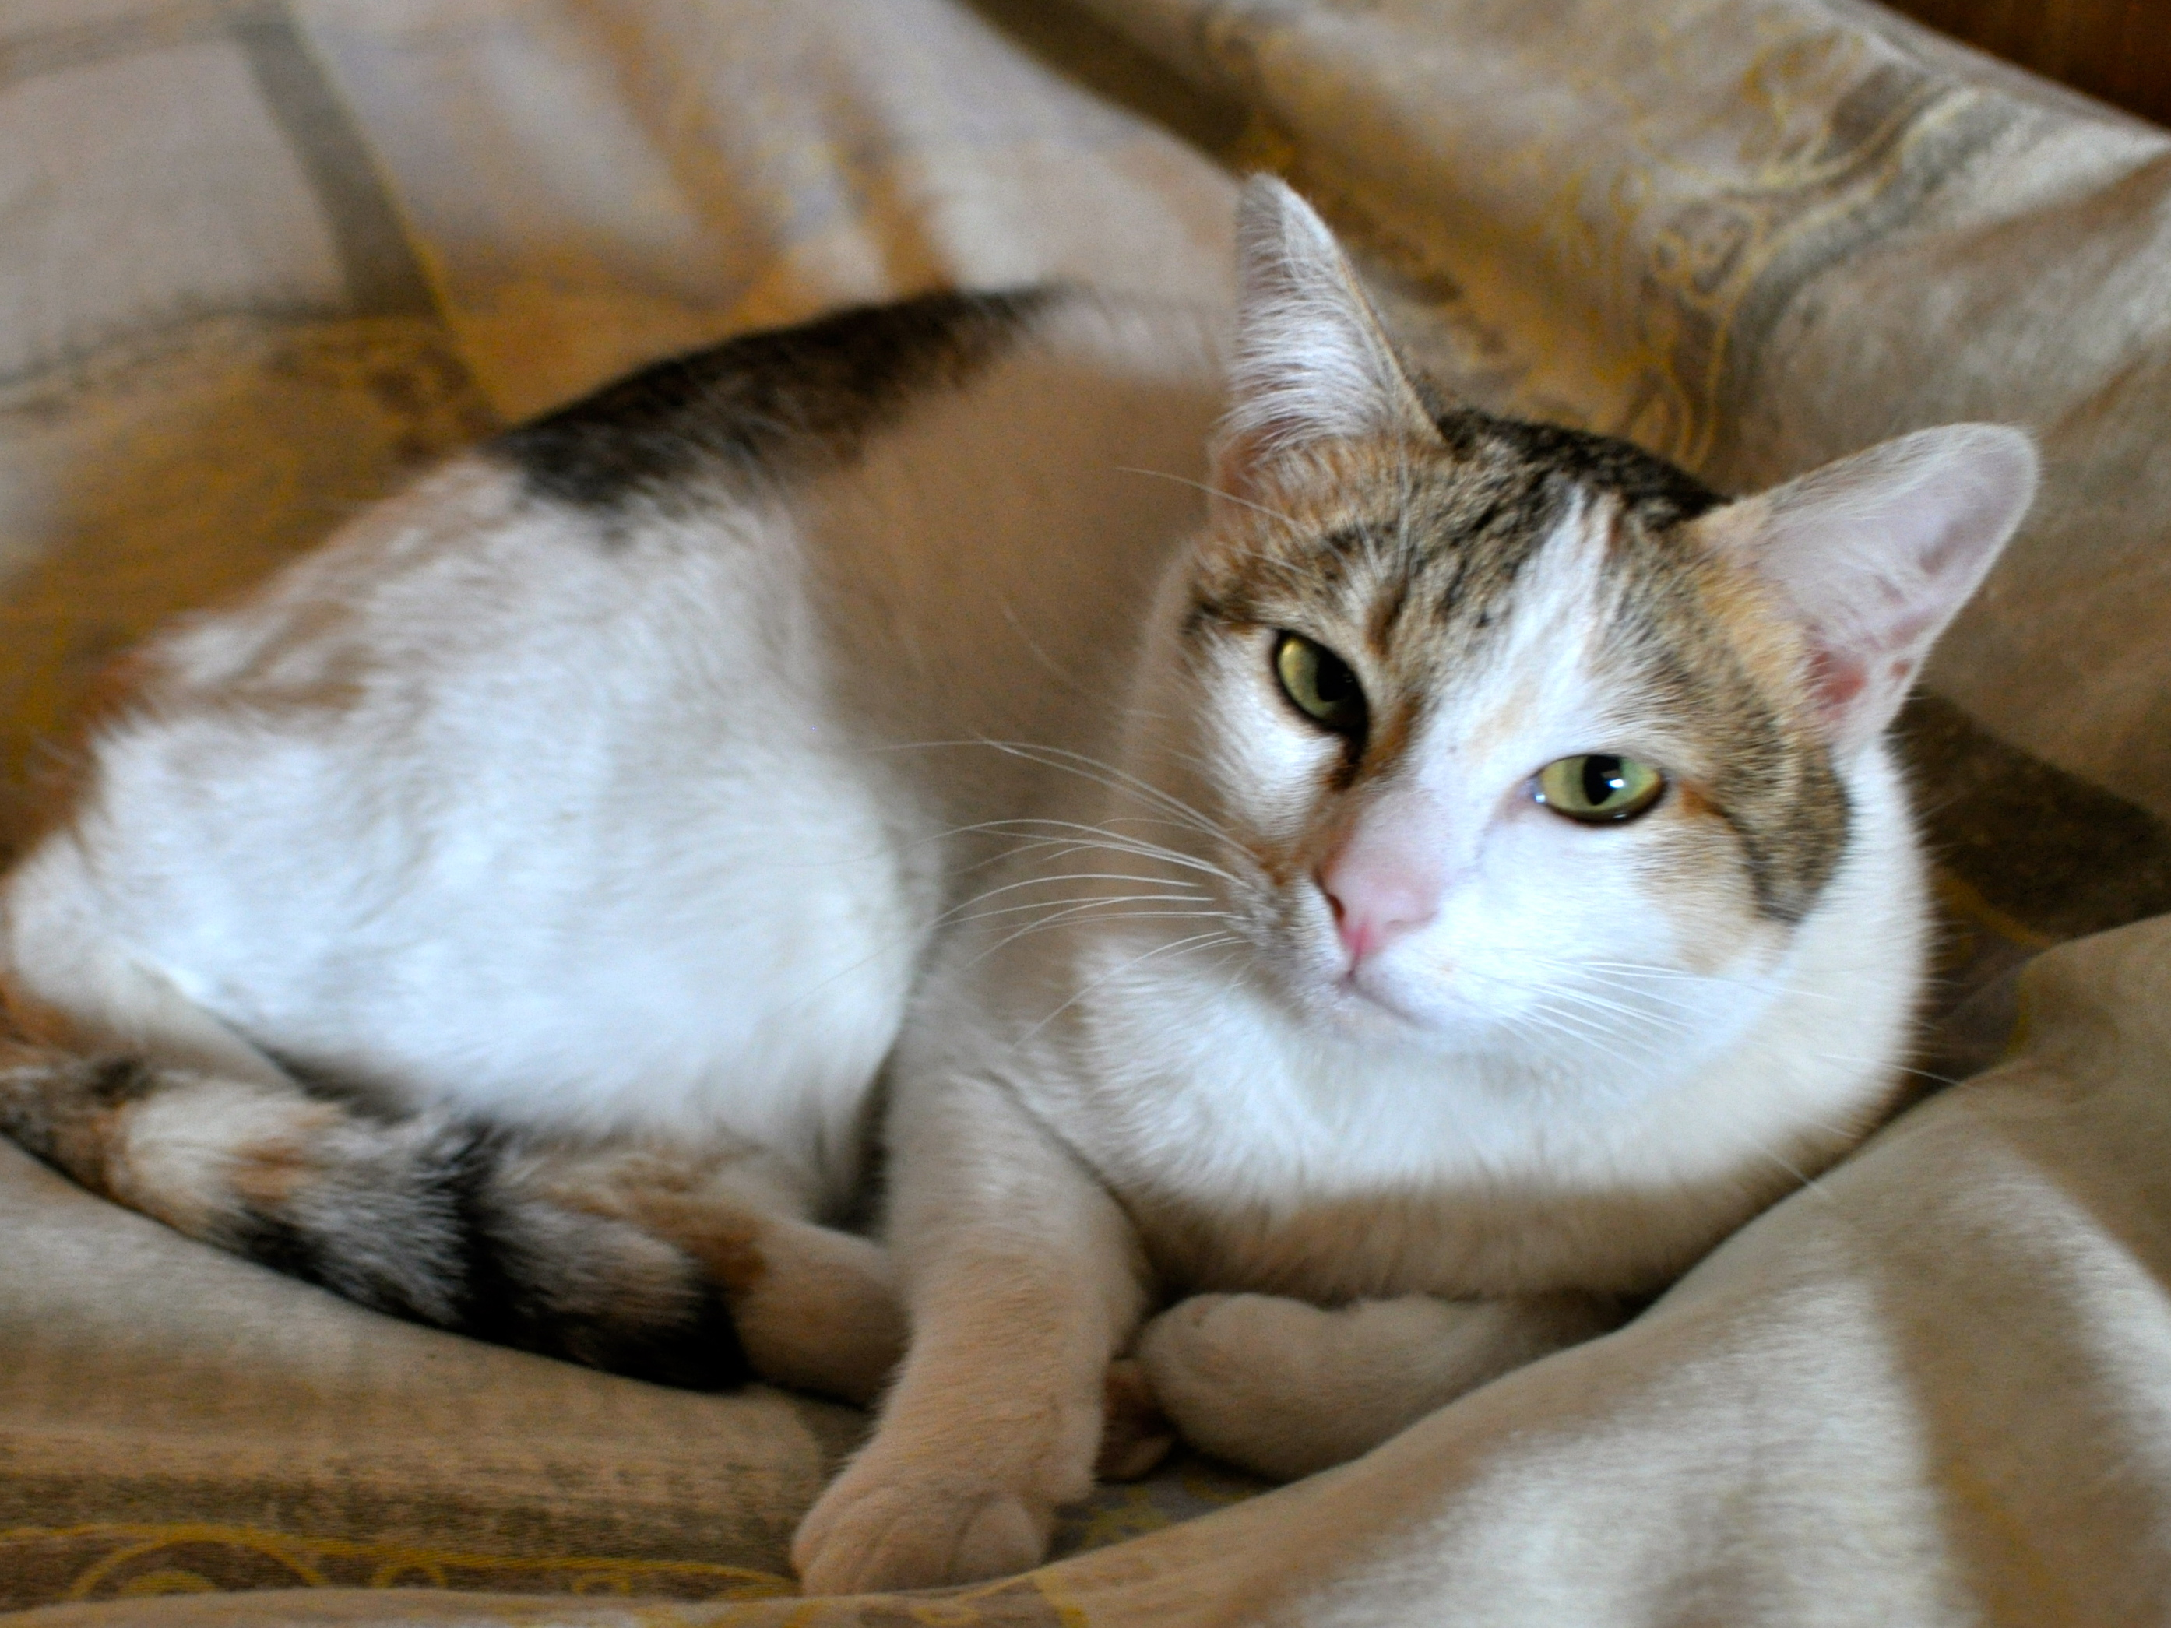

kata kitis sWirdeba axali patroni. is jer 2 wlis araa da ayvanili iyo taZridan kambojaSi. aris Zalian mosiyvarule da did movlas ar saWiroebs. kiti aris sterilizebuli, acrili da gakreWili.

karg mosiyvarule ojaxSi kiti miva Tavis sakuTari savarcxliT, satarebeli galiiT, patara yuTiT da dasagebiT.

ayvanis msurvelebma, gTxovT, daukavSirdeT siu koulis mobilurze 595 114996 an el- fosta suej.cowley@gmail.com

